Library concerned: Patricia Bowen Library & Knowledge Service, Chelsea and Westminster Hospital NHS Foundation Trust, West Middlesex Hospital site.

Name of case study: Clinical Librarian Outreach Service in Women’s Health and Maternity Unit
Interviewee | Dr Joana Girling  Consultant in Obstetric Medicine, Obstetrics and Gynaecology  Lead Division 3 and Speciality Lead Reproductive Health & Childbirth NW London CRN  West Middlesex University Hospital, and Chelsea Westminster NHS Foundation Trust  Twickenham Road  Isleworth  TW7 6AF  Joana.Girling@chelwest.nhs.uk
Interviewee | Please note: you should only provide interviewee details here if consent  to share on the national blog has been obtained
Summary of problem or reason for enquiry | West Middlesex University Hospital (WMUH) is a busy hospital serving a multicultural population in west London and delivering around 5000 babies annually. The librarians at West Middlesex University Hospital (WMUH) initiated a project in May 2016 with the Women’s Health and Maternity departments, to enhance provision to clinicians of evidence-based information related to patient care.
Brief description of the information found / service provided | The Librarians met with me and we discussed the ideas. I was impressed with the concept of bringing Librarians into the Clinical work place, and felt this was a good opportunity to improve our clinical care.  The aims were to increase awareness of Library services amongst health care professionals, and facilitate access to evidence based medicine for Clinicians. We agreed to start this as a pilot project in the department.  A Librarian visits the maternity unit once a week during the Obstetric Medicine and Preterm Birth Clinic, meeting clinicians in person in the Antenatal Clinic and on the Antenatal ward and Delivery Suite, acting as a visual reminder of the service and allowing discussion about what the outreach service offers .  The Librarians receive information requests from the WMUH Women’s Health and Maternity department through:  - Weekly visits to the department as outlined above  - Attending Obstetric Haematology multidisciplinary meetings and multiprofessional Maternity forum meetings.  - emails  After receiving the clinical query, the Librarian carries out an expert literature search of the available evidence using a range of resources and provides relevant information to the requesting clinician. This is usually done on the day of the request or the following working day.  The evaluation of the pilot (see below the embedded report) 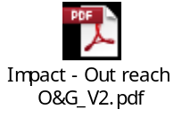  Shows that the response to this service has been universally positive and so the Library has decided to continue to provide this service.  2017-18 – 76 requests  2018-19 - 64 requests  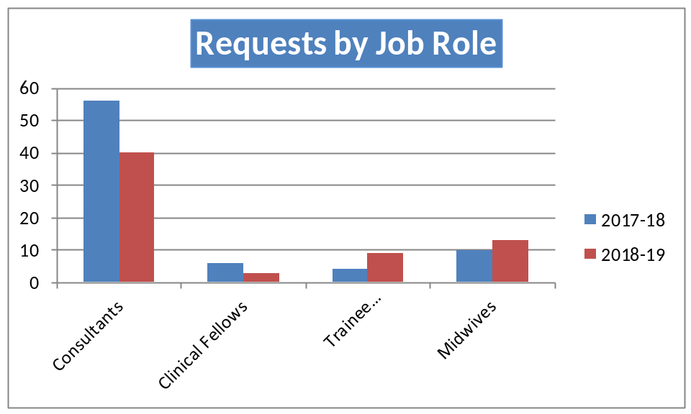  The Library has created an online repository of clinical questions requested by the O&G team so that they can access the evidence any time for future reference (http://www.library.wmuh.nhs.uk/wp/library/obstetrics-gynaecology-clinical-questions/clinical-questions/)

Summary of outcome and impact | The outreach service conducted by the library:  - Bridges the literature-practice gap, overcoming barriers to getting information into practice and making Librarians a valuable part of the clinical service  - Saved clinicians time for better patient care  - Provided Clinicians with quality-assured information at the point of need  - Ensured the best evidence is identified and enable clinicians to share evidence with colleagues and patients
Immediate Impact  (including quotes) | The service provided by the library optimises clinicians’ time immensely. The majority of the requests are for clinical decision making.  “We are so pleased to have the Clinical Librarian Outreach service, it really reminds us how important up to date clinical evidence is for patient care, and it is so quick and easy to get answers to the questions we can’t otherwise answer fully; it is also a great training opportunity for the midwives and junior doctors on the team.”  Some quotes from the team are:  - I am delighted that you are continuing this service, and that you are submitting your excellent work.  - Excellent service.  - I was very pleased with the quick service that the library offered  - The service at WMUH library has been absolutely excellent - fast, thorough and really helpful. Would highly recommend it.  - Very quick response time with high quality results  - The service at WMUH library has been absolutely excellent - fast, thorough and really helpful. Would highly recommend it.  - Library service is very valuable and much appreciated by Obstetric Medicine team  Some comments by the team on the impact of the evidence provided:  - Able to share recent evidence with a woman in order to help them to make decisions regarding breast cancer and chemotherapy during pregnancy  - Patient with advanced breast cancer presenting in pregnancy requiring chemotherapy. Literature search of recent case studies confirmed concerns about the standard treatment GCSF which is not safe in pregnancy  - The evidence/ knowledge used to counsel patient in clinic  - Cost benefit analysis has short term and long term implications on purchasing. research is incredibly helpful to make an informed decision  - Improved immediate care for patient concerned and facilitated swift and relevant tertiary referral  - Individual funding request for a biologic drug for a patient who didn't meet national criteria  - The patient whose situation triggered this literature search had an  unknown cause for her extreme short stature; the review ensured all aspects of care were fully considered  - The department now has an increased awareness of this rare condition & will be more able to diagnose this pathology  - The results have now been added into the appropriate local guideline and will be a change in how care is given  - This literature enabled us to update our intrapartum care guideline knowing that it is safe for women with a BMI above 35 to access a birth centre environment

